IU2541230084 - CPP56 - PROJECT REPORT
Faculty Leave Management
Enrollment No.: IU2541230084
Student Name: Yash Gupta
Semester: 3
Subject: C++ Guided Project

1. Introduction
The Faculty Leave Management project is a console-based C++ program for keeping faculty and department records and handling leave requests. A faculty member can apply for leave, and a manager can approve or reject a request. The program uses classes, functions, arrays, loops, conditions, and text files. It is designed as a small academic project that can be explained step by step.

2. Problem Statement
When leave requests are tracked manually, it can be difficult to find old requests, calculate the number of leave days, or see whether a request is pending, approved, or rejected. The program provides one menu-based place to keep faculty information and leave history and saves the records so they remain available after the program closes.

3. Objectives
The main objectives are:
- Store faculty and department records.
- Search, update, and delete records when it is safe to do so.
- Allow faculty leave requests with date validation and duration calculation.
- Record an approval or rejection decision.
- Generate a simple status report.
- Demonstrate the required C++ OOP concepts and text-file handling.

4. Functional Requirements
1. Add faculty or department records.
2. Display all stored records.
3. Search by faculty ID, department ID, or leave request ID.
4. Update faculty name and department.
5. Delete an unused faculty or department record; protect records linked to leave history.
6. Apply for leave and calculate inclusive leave days.
7. Approve or reject a pending request and store the decision.
8. Generate a report and save/load data files.
9. Check menu choices, IDs, date format, date order, and file errors.

5. System / Project Flow
START -> create LeaveSystem object -> load records from Data/ -> show menu -> user selects an operation -> LeaveSystem validates input and works with record classes -> FileManager saves or loads text files -> return to menu -> save on Exit -> END.

6. Class Descriptions
Class | Data Members | Member Functions | Responsibility
Faculty | facultyId, name, department | Faculty(); getId(); updateDetails(); display() | Stores one faculty member.
LeaveRequest | requestId, facultyId, type, fromDate, toDate, status | LeaveRequest(); calculateDays(); setStatus(); display() | Stores a request and its current status.
Department | departmentId, name | Department(); getId(); display() | Stores a department.
Approval | approvalId, requestId, managerId, status | Approval(); approve(); reject(); display() | Stores a manager decision.
LeaveSystem | pointers to four arrays; record counts | addRecord(); searchRecord(); processTransaction(); report(); saveNow(); loadData() | Coordinates menu operations and record arrays.
FileManager | file streams | save(); load() | Writes and reads the text data files.
Displayable | virtual display() | display() const; virtual destructor | Base class for runtime polymorphism.

7. OOP Concepts Used
Classes and objects: Faculty, Department, LeaveRequest, Approval, LeaveSystem, and FileManager represent records and program responsibilities. Encapsulation: record variables are private and accessed through public functions. Constructors: default and parameterized constructors initialize objects. Destructor: LeaveSystem releases allocated arrays with delete[]. Inheritance: four record classes inherit from Displayable. Runtime polymorphism: display() is called using a Displayable pointer. Dynamic memory: LeaveSystem creates arrays with new[] for a capacity of 100 records per type. File handling: FileManager uses ifstream and ofstream. Validation and exception handling: invalid dates and file/input problems are reported through checks and try/catch.

8. File Handling and Data Persistence
FileManager uses plain-text files in the Data folder. Each line is one record, and the vertical bar character (|) separates fields. faculty.txt stores faculty ID, name, and department; departments.txt stores department ID and name; leave_requests.txt stores request ID, faculty ID, type, start date, end date, and status; approvals.txt stores approval ID, request ID, manager ID, and decision. On startup the program loads the existing files. On exit it saves the current records. Missing files on the first run are treated as empty. The project must be run from the main project folder so the relative Data path is correct.

9. UML Diagrams
9.1 Use Case Diagram
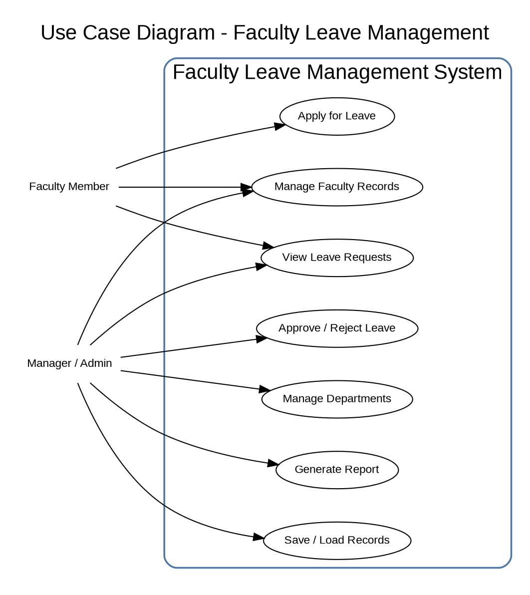
9.2 Class Diagram
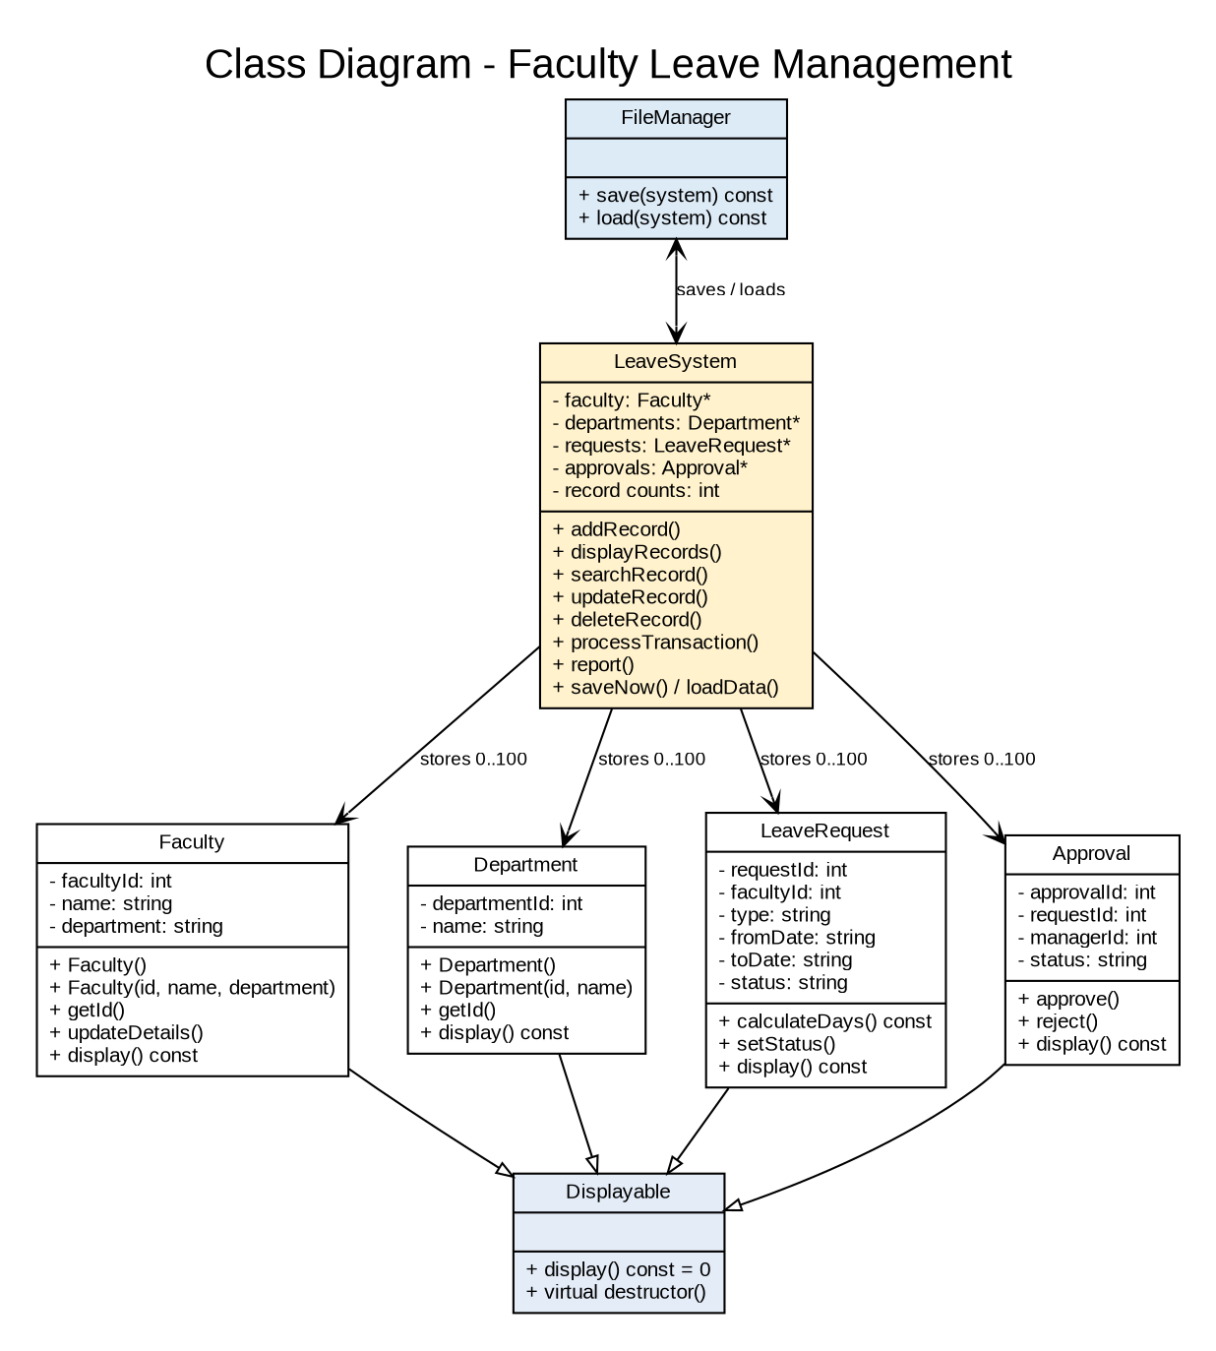
9.3 Sequence Diagram 1 - Apply for Leave
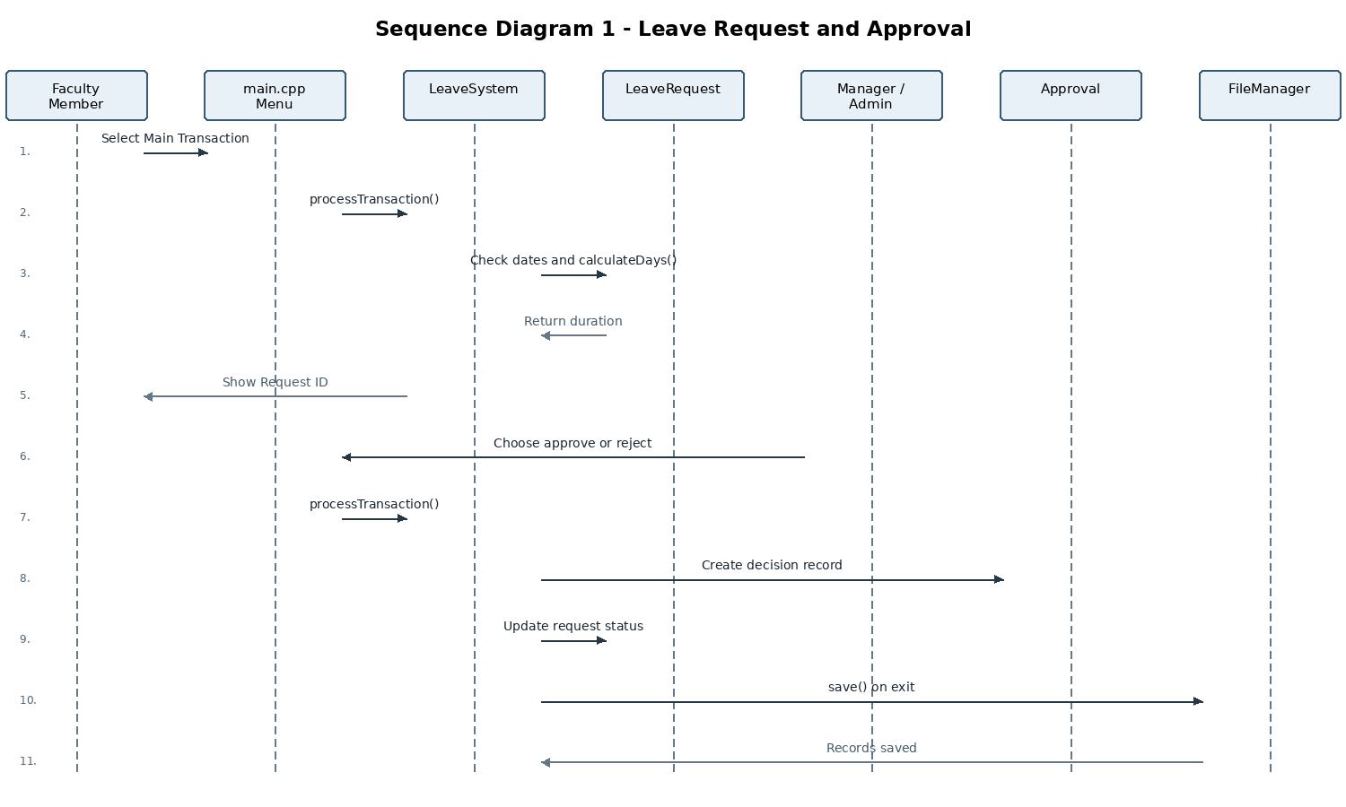
9.4 Sequence Diagram 2 - Search Record
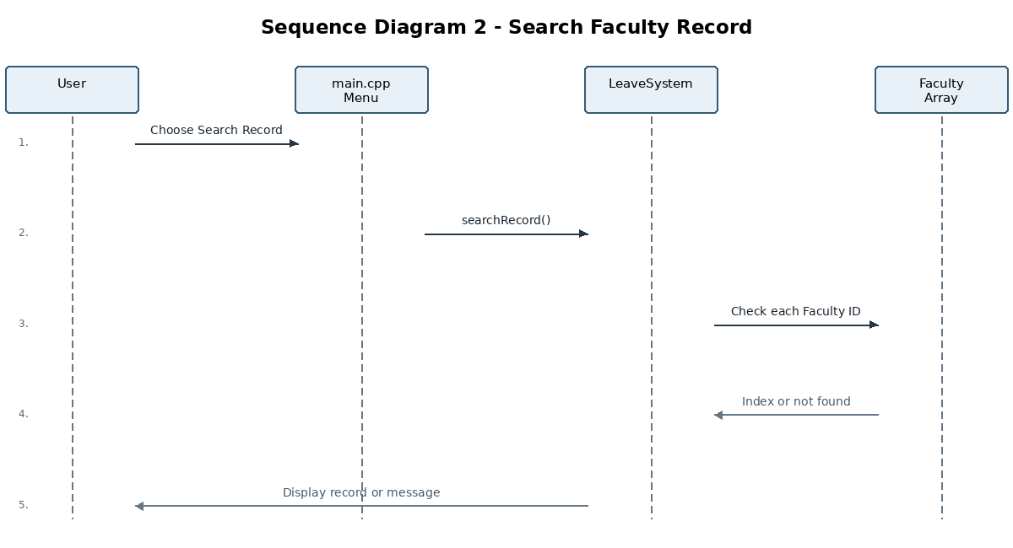

10. Implementation Details
The application is written in C++17 and separated into header (.h) and implementation (.cpp) files. main.cpp displays the menu and calls LeaveSystem functions. LeaveSystem stores four arrays, each with a maximum of 100 records, allocated using new[] and released in its destructor using delete[]. The record classes contain the data and display/update methods. LeaveRequest validates dates in YYYY-MM-DD format and calculates the inclusive duration. FileManager saves and reloads four text files. The Windows build script compiles all source files together, avoiding undefined-reference errors caused by compiling only main.cpp.

11. Testing and Results
Test ID | Input / Operation | Expected | Actual | Status
T01 | Add Dept; ID 1 | Added | Dept added | PASS
T02 | Add Faculty; ID 101 | Added | Faculty added | PASS
T03 | Display records | Records shown | Records shown | PASS
T04 | Search ID 101 | Faculty shown | Faculty found | PASS
T05 | Search ID 999 | Not found | Not found | PASS
T06 | Update ID 101 | Updated | Updated | PASS
T07 | Delete unused Faculty | Deleted | Deleted | PASS
T08 | Leave: 20-22 Oct | 3 days | 3 days | PASS
T09 | End before start date | Refused | Request refused | PASS
T10 | Approve request 1 | Approved | Approved | PASS
T11 | Reject request 1 | Rejected | Rejected | PASS
T12 | Duplicate ID 101 | Refused | Duplicate refused | PASS
T13 | Delete with history | Blocked | Deletion blocked | PASS
T14 | Close / restart | Data retained | Data retained | PASS
T15 | Menu choice 77 | Invalid message | Invalid message | PASS

12. Sample Screens / Output
The following console captures were generated from actual executions of the program in the available test environment. The Windows version should also be run locally if screenshots from the target system are required.
Figure 12.1: Main menu

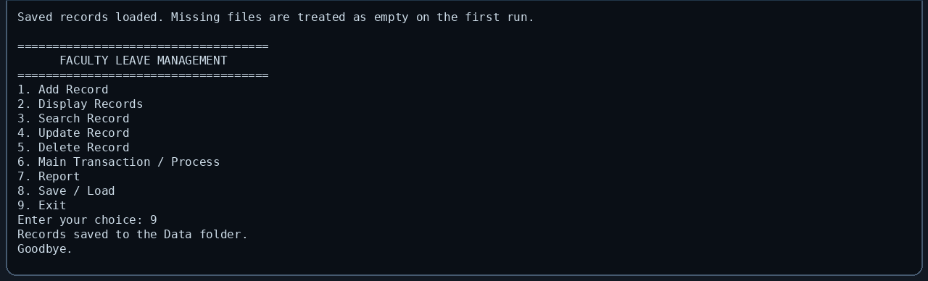
Figure 12.2: Adding a faculty record

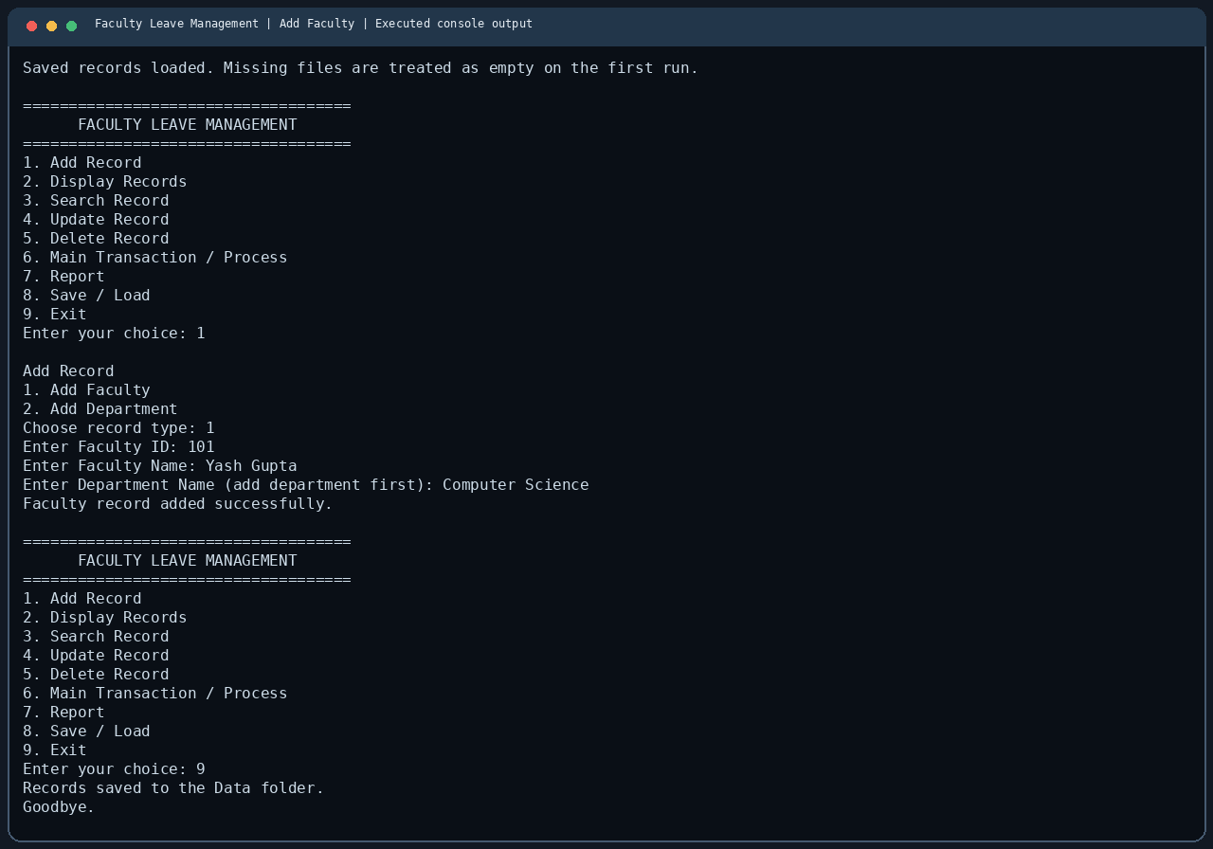
Figure 12.3: Applying for leave

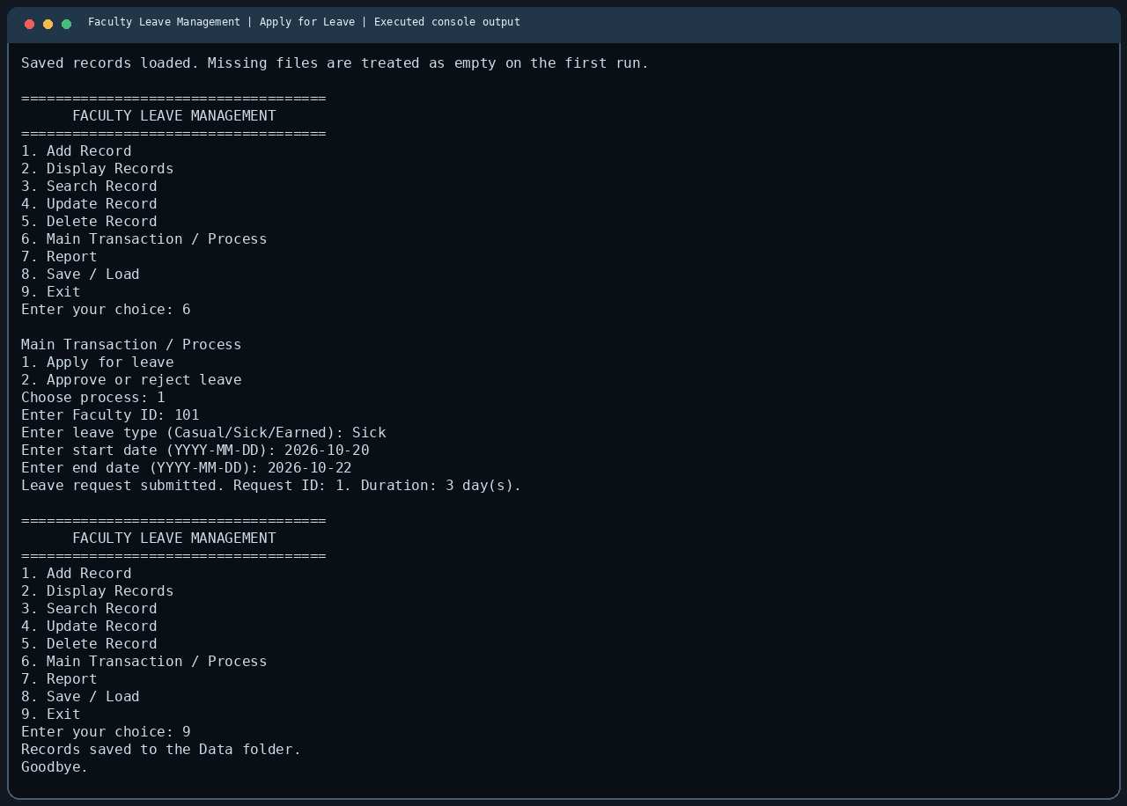
Figure 12.4: Report output

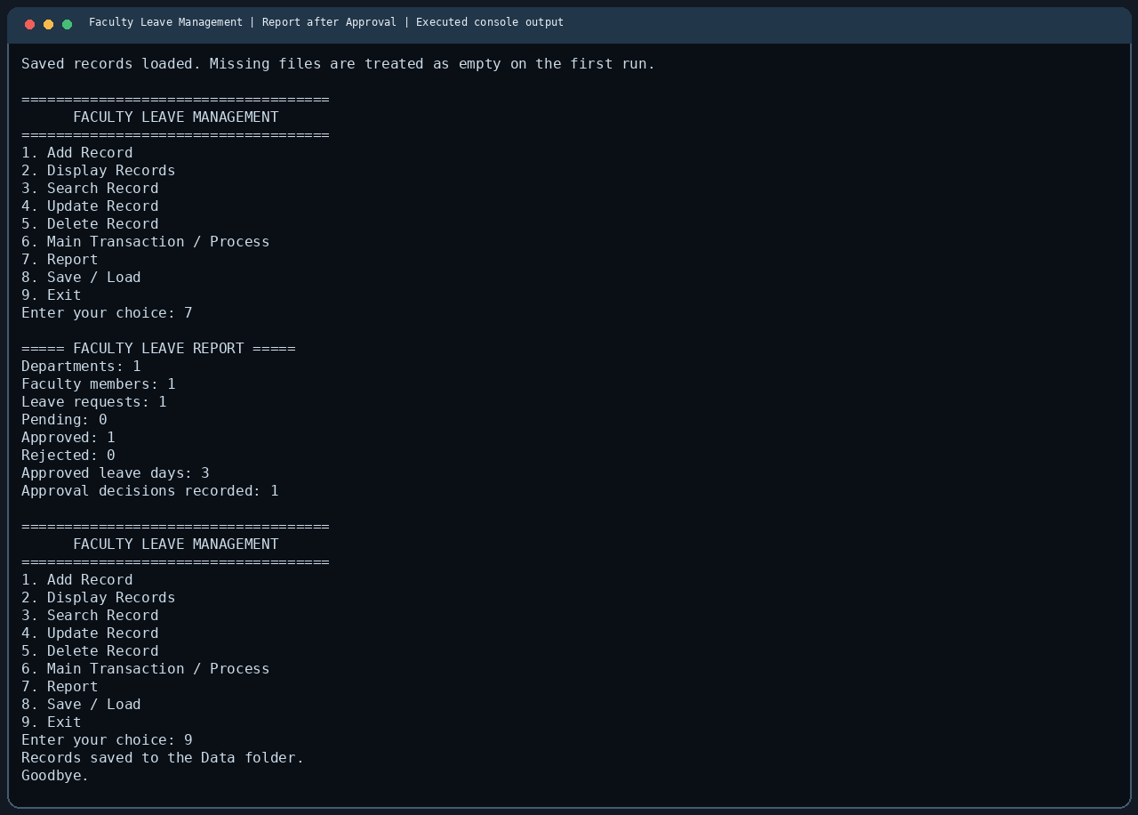

13. Limitations
The system is limited to 100 records per record type. It runs in a console and uses local text files rather than a database. It does not have user login, encryption, online access, email messages, or a graphical interface. The user should not enter the | separator inside a text field. Native Windows compilation still needs to be verified on the target computer before submission.

14. Future Scope
Possible future improvements include a graphical interface, a database, login roles for faculty and managers, leave balance rules, automatic notifications, and a more detailed report. These are future ideas and are not claimed as features of the current implementation.

15. Conclusion
The Faculty Leave Management project demonstrates a small but complete C++ console workflow. It manages faculty and department information, accepts and processes leave requests, calculates durations, records approval decisions, and saves data between runs. The implementation is intentionally kept beginner-friendly so the classes, arrays, loops, functions, inheritance, and file handling can be explained during the viva.

